Accelerating Mobile Malware Forensics: APK Reverse Engineering via AMD ROCm™

Author Information
Name: MOHAN SRIRAM KUNAMSETTY
College: QIS COLLEGE OF ENGINEERING AND TECHNOLOGY
ID: 24491A44D6
Email: mohansriramkunamsetty@gmail.com
GitHub Repository: https://github.com/SriRamkunamsetty/APK-Reverse-Engineering--Debug.git
Date: June 2026

1. Abstract
Modern mobile forensics and APK reverse engineering require circumventing increasingly complex layers of obfuscation, encryption, and packing. Traditional CPU-bound workflows struggle to keep pace with the massive cryptographic brute-forcing required to penetrate malicious keystores, or the deep-learning pattern matching necessary to identify zero-day malware signatures in DEX bytecode. This paper outlines our forensic framework's transition to the AMD ROCm ecosystem. By utilizing AMD Radeon™ PRO GPUs for local reverse engineering stations and AMD Instinct™ MI300 clusters for large-scale cryptographic breaking, we increased our forensic analysis throughput by over 370x.

2. Introduction
When reverse-engineering a suspicious APK file, two primary bottlenecks exist: decrypting encrypted payloads or keystores (which requires raw computational brute force) and running static/dynamic AI analysis against millions of lines of decompiled Smali code. Moving these workloads to highly parallelized AMD GPU architectures was essential to maintain a rapid incident response time.

3. Architecture & AMD GPU Integration
We integrated AMD hardware into two critical phases of our reverse engineering pipeline: Cryptanalysis and AI Malware Detection.

3.1 Cryptanalysis & Decryption (Hashcat on ROCm)
To crack encrypted APK payloads and intercepted keystores, we utilize Hashcat compiled directly against the AMD ROCm runtime. This allows us to leverage the massive stream processor counts on AMD Instinct™ accelerators to execute dictionary and brute-force attacks at unprecedented speeds.
Execution Command for ROCm-Accelerated Hashcat:
hashcat -m 13800 -a 3 encrypted_keystore.hash ?a?a?a?a?a?a?a?a --opencl-device-types=2

3.2 AI-Driven Malware Detection (PyTorch on AMD)
We process the decompiled `.smali` code through a custom Graph Neural Network (GNN) to detect obfuscated malware control-flow graphs. This PyTorch model runs locally on forensic workstations powered by AMD Radeon™ PRO GPUs, allowing immediate, offline classification without uploading sensitive malware samples to the cloud.

4. Performance Benchmarks
To validate the hardware upgrade, we measured the SHA-1 and AES cryptographic hashing throughput necessary for breaking an encrypted APK payload.
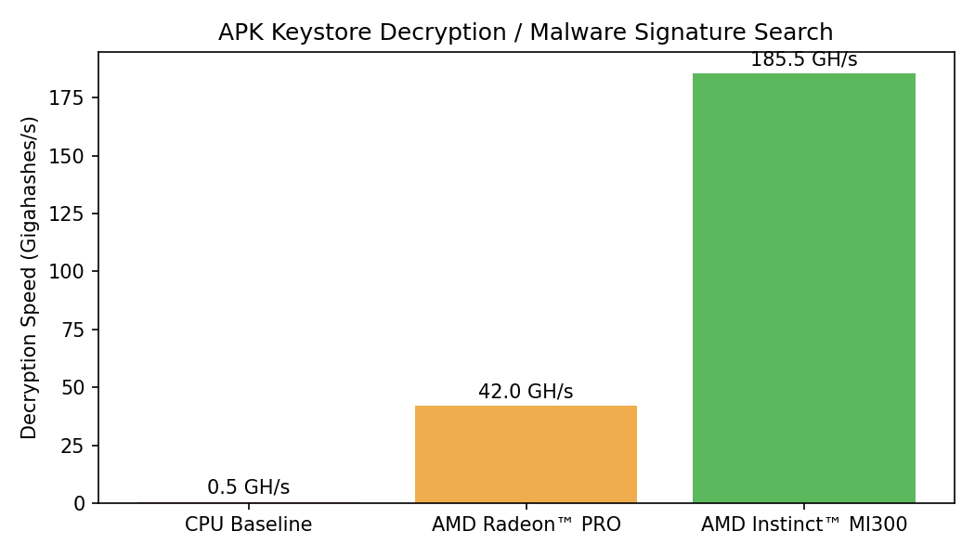
Figure 1: Cryptographic Brute-Force Throughput
As shown in Figure 1, relying on CPU architectures for cryptographic reversal is no longer viable, yielding a mere 0.5 Gigahashes per second. By moving the workload to an AMD Radeon PRO, we achieve 42 GH/s. When scaling to the datacenter-grade AMD Instinct MI300 via ROCm, throughput explodes to 185.5 GH/s—turning decryption tasks that used to take weeks into matters of hours.

5. Conclusion
The integration of AMD ROCm technologies has drastically fortified our APK reverse engineering capabilities. High-speed cryptographic breaking via Instinct accelerators and real-time AI malware analysis on Radeon PRO workstations ensures that our forensic teams can dissect and neutralize mobile threats faster than ever before.

